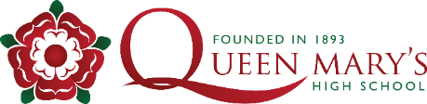
Uniform

At Queen Mary’s High School we have appointed Stevenson’s as our uniform stockist. Please visit their website for further details on how you can order. There are also some instructional videos on our website.
The list below details the uniform requirements for new starters. Details of our uniform policy can be found on our website: QMHS Uniform
COMPULSORY UNIFORM | PRICE (Variations depending on size)
Bottle Green Blouse long or short sleeve | From £15.25
Bottle Green Sweater with Emblem | £17.75 - £23.75
Bottle Green Pleated Skirt (knee length) | £28 - £34
Black Trousers with School motif | £22.75 - £28.75
QMHS Black Blazer with School Badge | £35.50 - £43.50
Technology Apron (Optional)
Black Tights or Black / White Socks (any supplier)
Black Shoes (any supplier)
PE KIT
School Branded Sports Polo Shirt | £19.50 - £27.50
School Branded Microfibre Skort | £19 – £24.00
School Branded Black Tracksuit Bottoms (highly recommended) | £19 - £25.50
School Branded Midlayer Training Top (highly recommended) | £25 - £35.50
School Branded Zip up Showerproof Jacket (highly recommended)
Plain (non branded) Black Leggings with Lycra (highly recommended and can be purchased from any supplier) | From £17
White Ankle Sports Socks (any supplier)
Football boots (not needed until the summer term)
Training Shoes - these should have non marking soles and be suitable for activities which involve running (leisure trainers and canvas pumps such as vans are not suitable)
Further PE kit information can be found on the school website.

