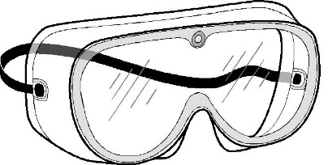
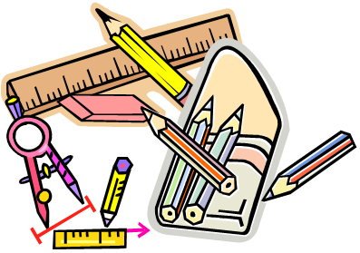

EQUIPMENT YOU WILL NEED

- Fountain pens with black or blue ink can be used for written work; biros, roller ball pens or those with liquid ink are acceptable alternatives.
- Pencils & sharpener
- Coloured pencils
- Rubber
- 30cm clear ruler and set square
- Compass
- Protractor
- Scissors and glue
- Rough notebook
- Bilingual Dictionary for your foreign language (all available from Amazon and priced around £5.00):
French: Oxford Essential French Dictionary
German: Oxford Essential German Dictionary
Spanish: Oxford Essential Spanish Dictionary
Mandarin: Details will be given in September
- A scientific calculator & art equipment is purchased from school

Science goggles, exercise books, textbooks and a school planner will be provided by the school.

