Making a Positive Contribution
GOLD AWARD
Queen Mary founded our school in 1554. Will you continue to make a positive contribution to Queen Mary’s High School and develop important skills, inspired by our founder? Working at Gold we would expect you to take a higher level of responsibility and look at working with our wider community.
Exceptional passion for education for a woman of her era.

Inspired by creativity, she had a love for singing, linguistics and dancing
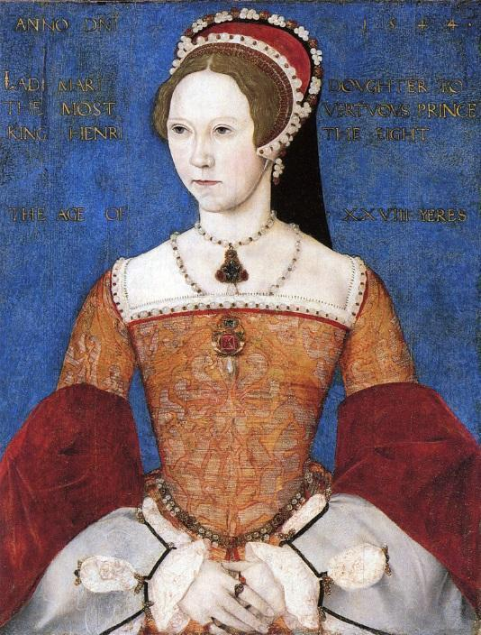
She gave generously to charity throughout her life.

Leadership as Queen of England July 1553 – November 1558.

She had great courage throughout her life, often standing up for her own beliefs.

To achieve this award, you must complete a task for each of the categories. Potential examples are listed, if you have others to propose please consult with your Form Tutor beforehand to avoid disappointment. The Director of Houses will be reviewing the final submission.

NAME_________________________________________ FORM_________________

Once you have collected your evidence, show a teacher and ask them to sign the badge and give a comment on the work you have created. Once you have completed all the badges then submit the record card and supporting information to your form tutor.

Creativity
Passion
Leadership
Independent Thinker
Courage
Charity

Skill | Gold aims | Examples
Independent Thinker | Career presentation, write and create a TED style presentation and deliver to a year group different to your own. | Research into a career you are interested in, find a topic that interests you and deliver a TED style presentation to a year group different to your own
Charity | Organise a charity event/volunteer with a local organisation not related to D of E/ work successfully as a subject/youth peer mentor for one year. | Work with a local hospital or care home and volunteer, volunteer with younger students for tuition, become a subject mentor.
Creativity | Attend a culture festival, celebrate a cultural event different to your own. Visit a gallery, museum or show outside of Birmingham. | Celebrate a different cultural festival than your own, go to a museum, art gallery in a different city. Create something to show what you have done
Courage | Share your Gold journey through a public platform. | Write a blog or keep a twitter diary of what you find and do. Share this with your peers or house leader
Passion- | Taking part in a club or activity that you enjoy outside of school. | Take part in a club for a minimum of 25 sessions, learn a new skill, could be in school or outside.
Leadership- | Completion of D of E bronze, silver or gold award or take a key role in school teams, or a regular activity outside of school or Gain PE Half colours. (Over at least 3 terms) | D of E expedition, leading a club, being part of the anti-bullying team. Being an ambassador for a subject or school council for at least a year.

Record card
 | Information about your action | Teacher comment and signature
Independent Thinker | Presentation topic:  Why you chose this: | Date:
Charity | The work I have completed: | Date:
Creativity | What did you attend and where? | Date:
Courage | How I have shared my gold journey: | Date:
Passion | - 6. 11. 16  - 7. 12. 17.  - 8. 13. 18.  - 9. 14. 19.  - 10. 15. 20. | Date:
Leadership | What I took part in:  How it helped me develop: | Date:
Reviewed and agreed by Form Tutor __________________________ Date ____________
Signed by Director of Houses _________________________ Date ____________

